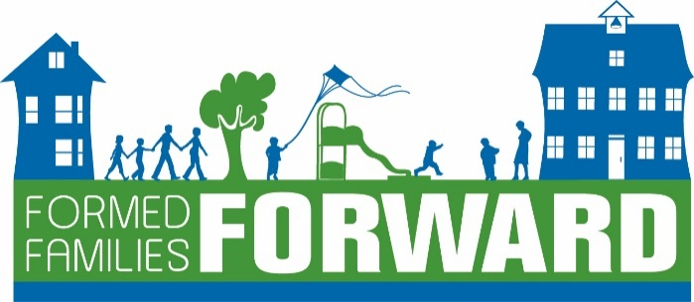

Resources for Foster, Adoptive and Kinship Military Families
Autism Speaks www.autismspeaks.org/
Blue Star Families https://bluestarfam.org/
Center for Parent Information and Resources https://www.parentcenterhub.org/
Child Welfare Information Gateway www.childwelfare.gov
Clearinghouse for Military Family Readiness at Penn State University https://militaryfamilies.psu.edu/
COVID-19 Military Support Initiative (CMSI) https://covid19militarysupport.org/
Department of Defense Education Activity (DODEA) https://www.dodea.edu/index.cfm
Early Childhood Technical Assistance Center https://ectacenter.org/
Family Service Centers-on military installations, can provide referrals, counseling, parent education, EFMP, spouse employment, family support
Families Overcoming Under Stress (FOCUS) www.focusproject.org
Formed Families Forward www.formedfamiliesforward.org
Ideas that Work-OSEP https://osepideasthatwork.org/
Military Child Education Coalition https://www.militarychild.org/about/
Military Kids Connect https://militarykidsconnect.health.mil/
Military Families Learning Network https://militaryfamilieslearningnetwork.org/
Military One Source www.militaryonesource.mil
National Military Family Association https://www.militaryfamily.org/
Office of Special Education and Rehabilitative Services-Department of Education https://www2.ed.gov/about/offices/list/osers/index.html
Parent Education and Training Center Military Outreach – PEATC
Parent Resource Centers in each school district
School Liasion Officers https://installations.militaryonesource.mil/search?program-service=12/view-by=ALL
Sesame Street for Military Families https://sesamestreetformilitaryfamilies.org/
Specialized Training of Military Parents (STOMP) https://wapave.org/specialized-training-of-military-parents-stomp/
Tutor.com https://military.tutor.com/home
United Through Reading http://unitedthroughreading.org/service-members/recording-locations/app/
Virginia Department of Education https://www.doe.virginia.gov/
Virginia Family Special Education Connection http://vafamilysped.org/
Virginia Infant Toddler Connection https://www.itcva.online/

Apps:
PTSD Family Coach is for family members of those living with posttraumatic stress disorder (PTSD). Developed by the Department of Veterans Affairs
Breathe, Think, Do with Sesame Developed by Sesame Workshop for Sesame Street for Military Families
LifeArmor Developed for the Defense Health Agency
Parenting2Go Developed for the Defense Health Agency
The Big Moving Adventure Developed by Sesame Workshop for Sesame Street for Military Families

